# Lab #1: MOSFET SPICE SIMULATION

Lab type: Group. Complete the lab tasks along with one or two more lab partners

Lab objectives: The objective of this lab is for you to simulate an N-channel MOSFET to determine it’s I/V characteristics and study the effects of changing the transistor dimensions such as length and width. LTSPICE is used for schematic capture and SPICE simulation.

## Pre-lab

The drain current ID of an N-MOSFET is given by the following expression

$I_{D}=\left\{\begin{aligned}0 V_{GS}<V_{TH} cut-off region \\ \frac{1}{2}μ_{n}C_{ox}\frac{W}{L}\left(2(V_{GS}-V_{TH})V_{DS}-{V_{DS}}^{2}\right) { V}_{GS}≥V_{TH} &and V_{DS}<V_{GS}- V_{TH} triode region \\ \frac{1}{2}μ_{n}C_{ox}\frac{W}{L}{(V_{GS}-V_{TH})}^{2} { V}_{GS}≥V_{TH} &and V_{DS}>V_{GS}- V_{TH} saturation region\end{aligned}\right.$

Determine the drain current at different VGS and VDS values and also specify the region of operation for the MOSFET in each case. Assume $μ_{n}C_{ox}=100μA/V^{2}$, $V_{TH}=0.7V$, $\frac{W}{L}=10$

Case1: VGS = 1.5V and VDS=0.5V

Case2: VGS = 0V and VDS=2V

Case3: VGS = 3V and VDS=3V

**You must show the prelab results (i.e., solution by hand in clear writing) to your instructor when asked. Failure to do so will result in poor lab grade.**

## Part#1: Schematic Capture

1. Using LTspice schematic capture, design the circuit shown in the figure below.

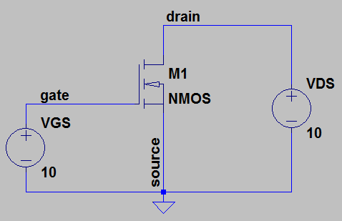

Figure 1: Circuit schematic to simulate the I-V characteristics of a MOSFET

To place an NMOS transistor in the circuit press ‘F2’ or go to Edit->Component in the menu and choose ‘nmos’ (NOT nmos4). Now, place the following spice directive in the circuit

.model nmos NMOS (kp=100u, vt0=0.5, l=0.18u, w=0.36u) (kp is $μ_{n}C_{ox}$)

To place the above spice directive, press ‘s’ or go to Edit->SPICE Directive and type the above linein the window that is opened and click ‘ok’. In the above spice directive, vt0=zero bias threshold voltage, l=length and w=width.

Again, add another spice directive to perform dc analysis i.e to allow SPICE sweep the input voltage across a range of values in sufficiently small steps

.dc VDS 0 10 0.01

Your circuit schematic should now look similar to figure shown below.

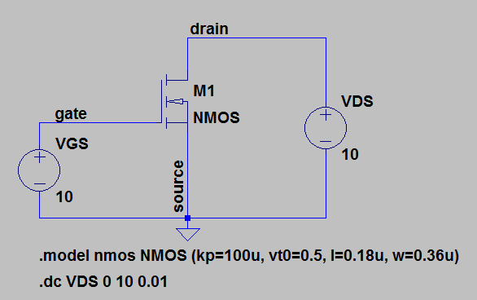

Figure 2: Circuit schematic with SPICE directives

**Show the completed schematic to the instructor.**

1. Justify the DC sweep results using theory. Mark Vth on the resulted graph. Does it equal the value of Vth that you assumed?

## Part#2: I/V Characteristics

1. Simulate and plot the ID – VDS and ID – VGS characteristics

For ID – VDS characteristic keep VGS value fixed and sweep VDS from 0V to 10V. Repeat this step for **five different values** of VGS between 0V and 10V. You need to display the ID-VDS curves for different VGS values on the same plot. To do this you may want to use the .step command in LTspice using the following steps.

* First, parameterize VGS by right clicking the voltage source VGS and then place {X} as the DC Value
* Then add the following spice directive “.step param X list 1 2 5”. This will allow you to plot the ID-VDS curves when VGS =1V, VGS=2V and VGS=5V on the same plot.

For ID – VGS characteristic keep VDS value fixed and sweep VGS from 0V to 10V. Repeat this step for five different values of VDS between 0V and 10V.

**Show the plotted I/V characteristics to the instructor.**

1. By looking at the generated graphs, explain why for every Id-Vds curve the maximum current points aren’t equal.

## Part#3: Effect of changing transistor dimensions

Now, simulate and plot the ID – VDS and ID – VGS characteristics for different transistor dimensions

1. Changing transistor length

For ID – VDS characteristic keep VGS value fixed and sweep VDS from 0V to 10V. Now, change the transistor length and repeat this step for five different values of transistor lengths between 0.09u to 0.6u.

For ID – VGS characteristic keep VDS value fixed and sweep VGS from 0V to 10V. Now, change the transistor length and repeat this step for five different values of transistor lengths between 0.09u to 0.6u.

1. Changing transistor width

For ID – VDS characteristic keep VGS value fixed and sweep VDS from 0V to 10V. Now, change the transistor width and repeat this step for five different values of transistor widths between 0.36u to 2.4u.

For ID – VGS characteristic keep VDS value fixed and sweep VGS from 0V to 10V. Now, change the transistor width and repeat this step for five different values of transistor widths between 0.36u to 2.4u.

**Show the plotted I/V characteristics to the instructor.**

1. Justify your findings theoretically and mathematically.
2. Using the Id-Vds curves only, determine how you can find Kp*W/L? Show this using an example from your data.